**GROUP NAME: Script Squad**

**APP NAME: Vital-Sync**

**GROUP MEMBERS**

**ST10028039 - Mehluli Booi**

**ST10185742 - Rebotile Molala**

**ST10092086 - Lwazi Mesatywa**

**ST10209476 - Lesego Ramosa**

**PATHWAY: OPSC7312**

**MODULE: Open-Source Coding (Intermediate)**

**Lecturer: Mr. Handsome Mpofu**

**DUE DATE: 30 September 2024**

**READ ME FILE**

**THE PURPOSE OF THE APPLICATION**

The Vital-Sync App aims to enable users to manage their health and wellness by tracking their diet effectively and receiving personalized health guidance. The app's goal is to make it easier to choose healthier lifestyle options by offering a user-friendly way to track food intake, control health profiles, and view nutritional data. The connection to a backend API guarantees that users can conveniently retrieve their information, get personalized dietary suggestions, and keep track of their advancements as time goes on. In the end, the goal of the application is to assist users in reaching their health objectives and enhancing their general well-being.

**DESIGN CONSIDERATIONS**

* **User friendly Interface**

The application is user friendly as it is easy to use allowing the user to input meals and monitor their health effortlessly.

* **Data and Privacy**

The application consists of a data and security feature using MongoDB as a database and a restful API which allows authorised users only. The security measures were used to protect the user's personal details such as their health information.

* **Performance Optimisation**

The application runs smoothly and optimally when the calls to the API are made. Data caching and various background processes were used to ensure that the user's experience is a seamless journey.

* **Feedback Mechanism**

Users were provided with immediate feedback to various activities such as logging the meals, or any updates made to the health information. Notification features were used to remind users regularly on tips to reach their fitness goals.

* **User Support**

There should be tutorials or onboarding experiences that will help new users understand how to navigate the app and make use of its features to the fullest. In order to assist users with issues they encounter, there will be support options available where the user can describe their issue when they click the contact us button.

* **Testing**

Making use of usability testing in order to gather feedback from real users, ensures that there will be iterative improvements based on their experiences. Regularly update the app to fic bugs, take action of user suggestions which will overall improve the functionality.

**THREE FEATURES**

* **Comprehensive Diet Tracker**

The Vital-Sync app allows users to log their meals easily, which provided a detailed overview of their daily calories, intake and their nutritional values. Individuals can easily search for food items, include them in their meal log, and see an overview of their nutrient intake thanks to a user-friendly interface. This function assists users in making educated decisions about their diet and maintaining progress towards their health objectives.

* **Personalised Health Profiles**

The users of the application have the ability to establish and personalize their health profiles by entering important details like age, weight, height, fitness objectives, and dietary tastes. The app uses personalized data to provide customized recommendations and insights, assisting users in comprehending their individual nutritional requirements and modifying their diets for maximum health benefits.

* **Tracking and Analytics**

The application offers users graphical displays of their eating patterns and wellness advancements over time using graphs and charts. Users have the ability to effortlessly monitor their calorie intake, nutrient distribution, and how well they are sticking to their fitness objectives. This aspect encourages users to remain dedicated to their health goals and also assists them in recognizing trends and opportunities for enhancement in their food selections.

**GITHUB ACTIONS**

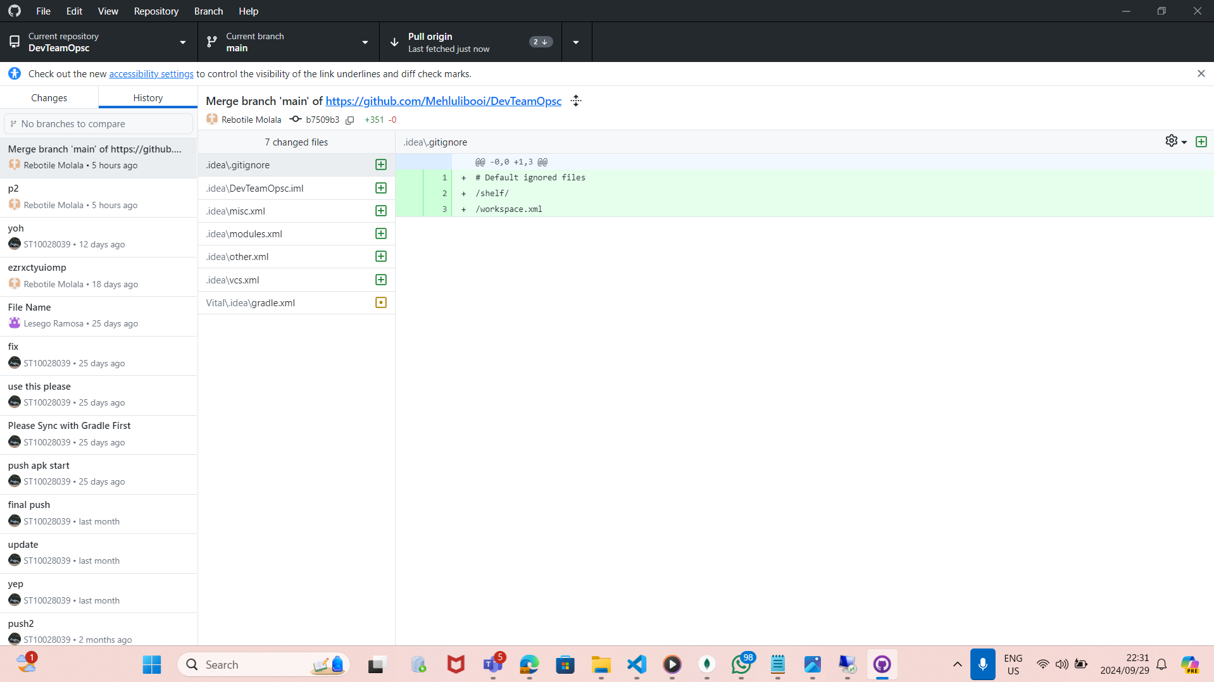

These are the GitHub actions that occurred in the group work. Mainly exchange of code was what was occurring. We utilized it cause the workflow was simple and it ensures code quality code as well as a improved collaboration between the team. We were able to pull and push code from one another, commit the new changes as well as merging the code together.

**API INTERGRATION**

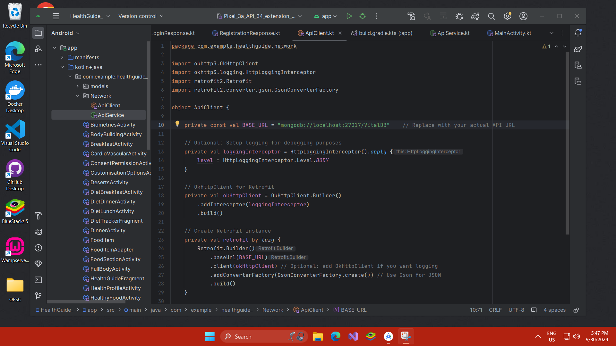

**USER MANUAL**

* **Welcome page**

The welcome page welcomes the user our application with a short a description of what the functionality is about. Below the page is a click here button that takes the user to the next page.

* **Registration page**

The registration page allows the user to register to the app using their username, email and password. The user clicks on the T&Cs box to accept the terms and conditions of using our app. Then the user clicks on the create an account button and also they have an option to sign in if they have an existing account.

* **Login page**

The user is then directed to the login page after registering where they can simply login using their username and password, then click the login button or alternatively they can sign-in if they have an existing account.

* **Health Profile Page**

Once the user is regarded as a user with the application, they are firstly required to share a little information about themselves. So, the user is requested to add their age, height, weight and sex then continue.

* **Dashboard**

The dashboard consists of a welcome user on the top, then a date on the right as well as notification bell that’s sends notifications frequently to the user. Then below that there is a daily goal where the user can see their number of steps, the distance they have walked as well as the water the user has consumed. On the right is a graph that displays the number of calories of the user. Then below is the information about the user they had inputted in the health profile page. The diet tracker page the navigation bar consists of four pages.

* **Diet Tracker page**

The diet tracker page has a notification button the top right which gives the user constant notifications. The page displays the number of calories the user has consumed, and the calories have burnt. On the top right a graph is displayed that shows the total calories for the specific user. Then below that is the of carbs, protein and fats left. The user can simply calculate the calories consumed by either clicking the breakfast, lunch as well as dinner. The diet tracker page the navigation bar consists of four pages. The continuation of the diet tracker page consists of a search bar which allows the user to search any type of food they would like to choose. The user is allowed to choose the food they would like so it could either be breakfast, lunch and dinner so when they click this they are directed to a specific page. Then after they have chosen the types of food the calories are calculated and displayed for the user based on the specific meal. Then the user can click the add to tracker button when they are done.

* **Health Guide page**

This is the health guide page that allows the user to select between the recipe section, the workout session or the food section. These pages help the user with their goals. The navigation bar consists of four pages.

* **Recipes page**

The recipe section allows the user to choose the recipe they would like to make, could be either the smoothies, dinner, lunch, breakfast or deserts. The top of the page has a back button on the top right that allows the user to navigate back to the dashboard page, then on the top right the page has a notification bell that updates the user with notifications.

After the user has chosen the specific recipe, they would like to create they are taken to one of the five pages depending on the recipe section they chose, then they can choose one of many recipes they would like to try then a display of the recipes is shown to them. The top of the page has a back button on the top right that allows the user to navigate back to the dashboard page, then on the top right the page has a notification bell that updates the user with notification

* **Workout page**

The workout section page gives the users an option to either choose between upper body, cardiovascular, lower body, and full body. From there they are given an option to choose their workout preferences. The top of the page has a back button on the top right that allows the user to navigate back to the dashboard page, then on the top right the page has a notification bell that updates the user with notifications.

From the health guide page if the user has clicked the workout section page they are directed to this page where they can select which workout preferences, they want that’s also suitable for them. They can either choose between beginner, intermediate and advanced. The top of the page has a back button on the top right that allows the user to navigate back to the dashboard page, then on the top right the page has a notification bell that updates the user with notifications.

* **Food section page**

The food section page basically allows the user to select whether they want to check information about the healthy food, power bites and body building. The top of the page has a back button on the top right that allows the user to navigate back to the dashboard page, then on the top right the page has a notification bell that updates the user with notifications.

* **Settings page**

The settings page consists of a back button on the top right that allows the user to navigate back to the dashboard page, then on the top right the page has a notification bell that updates the user with notifications. Below that is a search button for the user to search for anything they are looking for. The page has a sleeping mode button that allows the user to select whether its sleeping mode or day mode. Then next is a customisation button that allows the user to be able to customize the application according to their preference. The user is also allowed to read the privacy and security policy of the application. The user can also receive help and support when they click on the help and support button. The user is lastly allowed to rate the application.

Under the customisation page the user is allowed to choose their preferred language. The user us allowed to modify their height and weight. The user is allowed to modify their fitness goal and choose whether they want to lose weight, maintain their weight or gain weight. The user is lastly allowed to modify their fitness difficulty level whether they are beginner, intermediate or advanced. Then they can gladly save their modifications.

The biometrics page which the user will use to access the application, and they are officially authorised as a user. The user has the right to read through the privacy consent, the security consent and the permissions.

**Write-Up of the AI Tools Used:**

During our most recent Android development endeavour, we utilized a range of AI tools, particularly ChatGPT, to improve our workflow and address unique obstacles effectively. AI was incredibly helpful in the development of our dashboard design, showcasing its value in this key area. Through inputting "android Diet mock up picture Code" to ChatGPT, we obtained ideas for visual designs that aided in enhancing our understanding of the user interface. The picture offered clues on organizing components, guaranteeing a user-centric experience.

When we faced problems with overlapping selections in our design, we utilized the "Android Studio layout design" prompt to restructure and improve the layout. This direction helped us design a interface that is more user-friendly and visually attractive. Furthermore, we encountered an issue with the ScrollView arrangement in our XML file, and searching for "scrollView Layout fix" gave us a resolution, enabling seamless vertical scrolling in our app.

AI was also integral in improving our login page. By presenting the "Vital-Sync Fitness app Login Page," we were able to promptly pinpoint and resolve issues that were impeding the authentication process for users. Additionally, we sought information about a "Blog API" to improve our app's functionality. ChatGPT provided instructions on incorporating this API into our diet tracker application, enhancing our content delivery.

Making changes to the design of the health guide section posed another obstacle for us. Through requesting for "Xml Layout modification," we received specific changes that enhanced the overall layout. In addition, we looked for a "Privacy Consent message" example that would help guarantee user data security and privacy compliance.

In order to improve our settings page, we searched for "Input boxes Layout example" and found helpful suggestions for the layout. We asked for a "Green Colour code" to ensure the aesthetic consistency of our application's theme, leading to the creation of a harmonizing hex code. Finally, in order to make it easier to move between pages, we implemented a "List view navigation Code example" that helped us connect different sections smoothly.

Overall,  incorporating AI tools such as ChatGPT in our development process not only made our workflow more efficient but also greatly enhanced the quality and functionality of our Android app.